SCREENSHOT nomor 8 dari linux bible chapter 6

XEYES

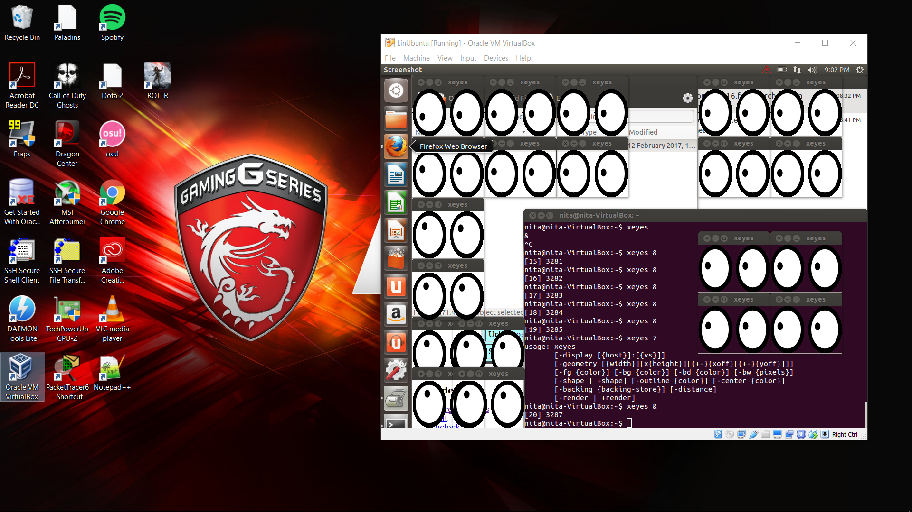

Killall command to kill all process of xeyes

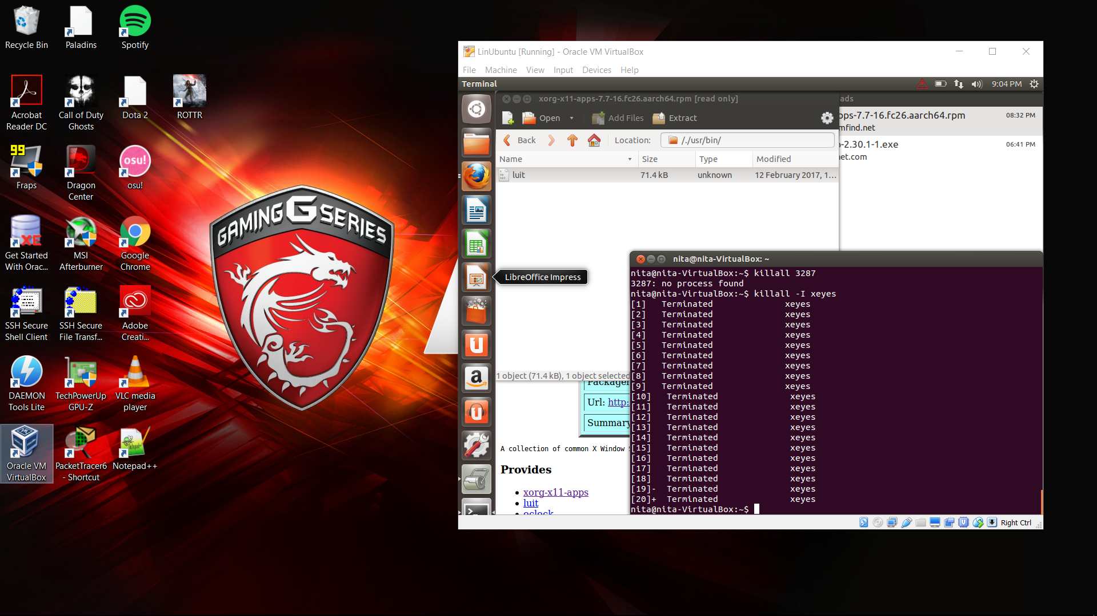

SCREENSHOT nomor 10 dari linux bible chapter 6

RENICE command

